Ques 1

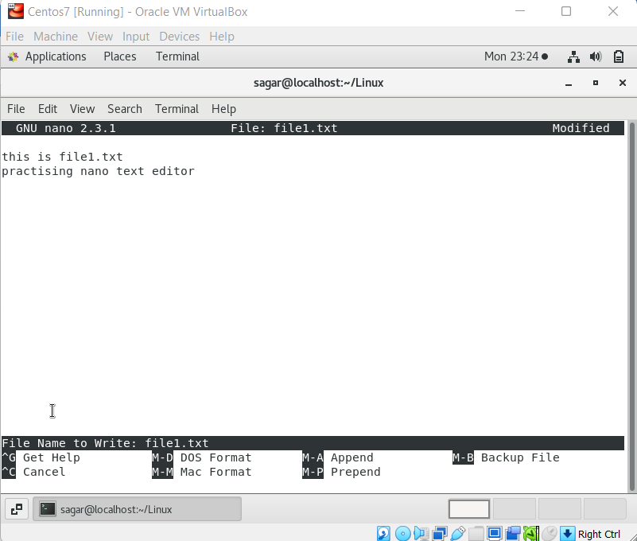

Ques 2

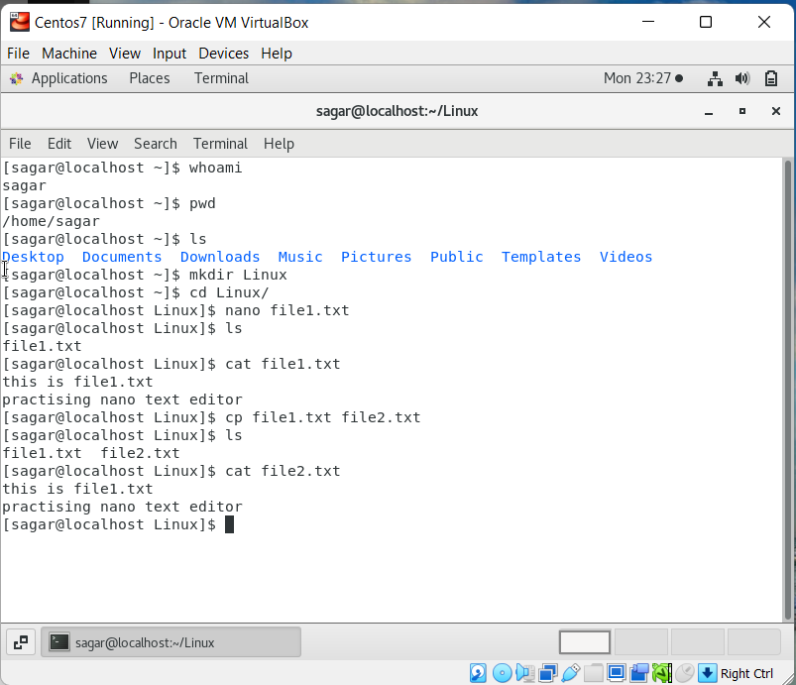

Ques 3

Ques 4

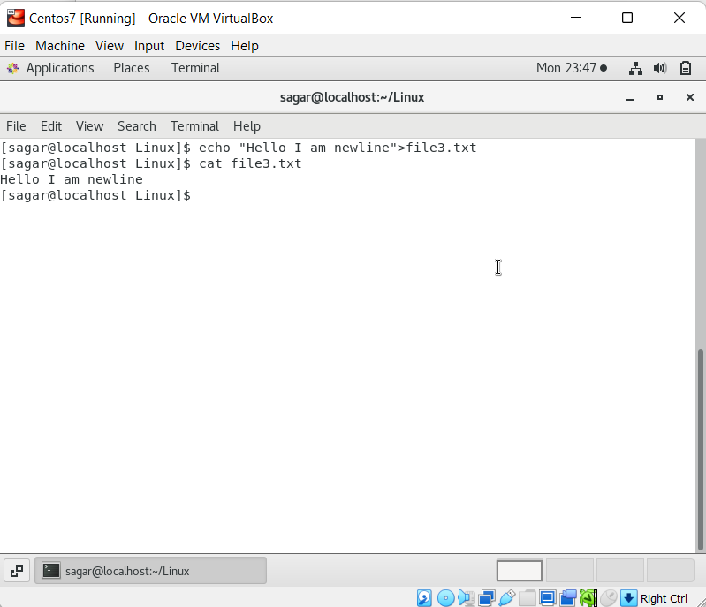

Ques 5

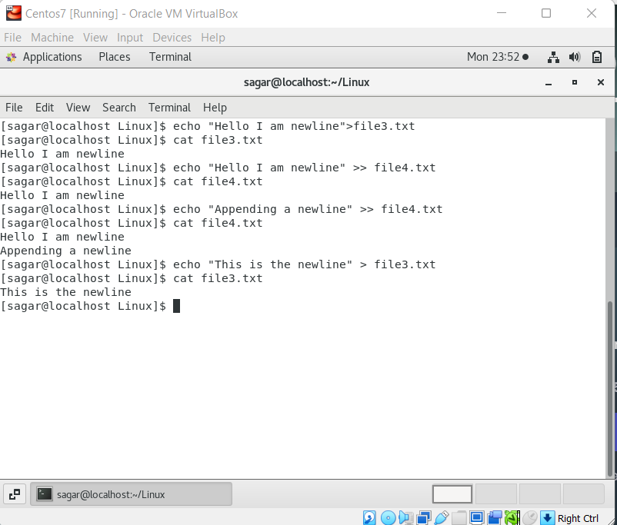

> truncate the file and adds the echo statement

>> Appends the echo statement to the file

Ques 6

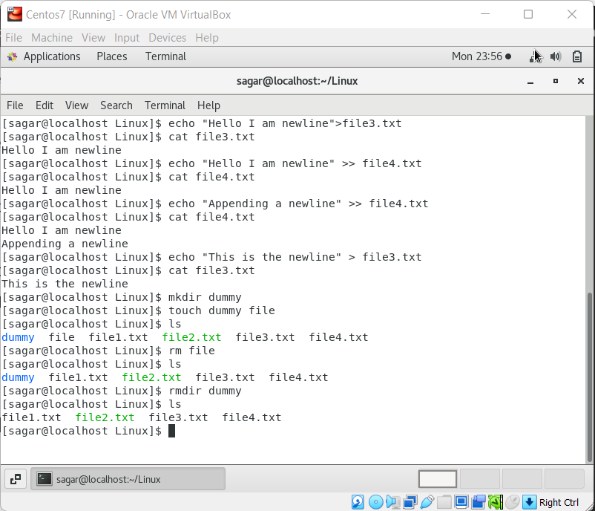

Dummy folder removed using rmdir command

File removed using rm command